**Calling All Crows, Unlocked Voices   
6.25.2020 Event with JDI - Action Alerts**

1) ***Learn more*** and support the advocacy of these organizations:

* #8toAbolition: <https://www.8toabolition.com/>
* Survived and Punished: <https://survivedandpunished.org/quick-statistics/>

2) ***Share*** one image/post on social media: visit <https://www.8toabolition.com/tweets> for helpful examples. Scroll down on the #8toAbolition [home page](https://www.8toabolition.com/) for featured infographics to share. Here’s an example:

* “Abolition can’t wait. Building off the work of Black feminist theorists and abolitionist organizers, we’re putting forward 8 actionable steps to move us closer to a world without prisons or police. [8toabolition.com](http://8toabolition.com/) #8toAbolition”

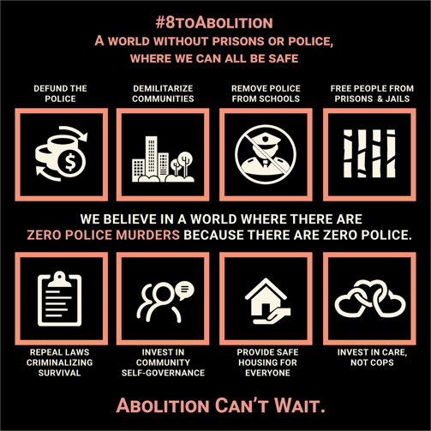

3*)* ***Discuss:*** Reach out to 2 friends or colleagues to talk about how your community would benefit from increased investment in community services and safety outside of the policing system. Share what you learned from the above websites.

4) ***Advocate:*** Call or send a personalized letter to your legislator(s) demanding the reallocation of resources to communities most impacted by mass incarceration. Copy and paste **the letter below** into an email or use it to guide your phone conversations.

For more information about JDI’s efforts to support the needs of those who experience and are impacted by sexual and domestic violence and our policy and systems advocacy work, visit <https://janedoe.org> or email [policy@janedoe.org](mailto:policy@janedoe.org).

**Invest In Communities, Not Prisons Letter Template:**

Feel free to cut and paste this template in an email or print and send it to your legislator. You can also use the text below to guide your phone conversations with government representatives. Consider adding a sentence about why this is important to you! Visit [this site](https://www.vote.org/about/) for help finding your legislators!

**Massachusetts residents!** Did you know that a $50 million women’s prison is set to be constructed in Norfolk, MA? Ask your MA legislators to invest in communities, not prisons:

* *“I oppose the construction of the new $50 million women’s prison in Norfolk, MA. Invest in our communities, not in mass incarceration.”*

[DATE]

[The Honorable NAME OF ELECTED OFFICIAL]

[Address]

[City, State] [Zip]

Re. Invest in Communities, Not Prisons: End Mass Incarceration in [YOUR STATE]

Dear [Representative/Senator LAST NAME],

I am writing because I am concerned about the problem of mass incarceration in our communities and wanted to know your position on this important issue. I recently learned about the work of organizations such as [#8toAbolition](https://www.8toabolition.com/) and [Survived and Punished](https://survivedandpunished.org/), both organizations that are actively working toward ending mass incarceration and over-policing of communities. Did you know that the majority of women in prison are survivors of domestic or sexual violence?

So many people in our prisons and jails have experience trauma in their lives. People need services in their communities, not prisons, to heal.

All people need safe and affordable housing, health care, and funds to support their basic needs. During the budget crisis that has been created by this pandemic, why not reallocate funds to communities most impacted by racism and police violence? Let’s invest in community-based solutions for healing and survival.

What are you doing to move funding away from policing and prisons and toward organizations that play an important role in increasing neighborhood and community health and safety, including the health of survivors of sexual and domestic violence? How are you ensuring that your communities have the resources they need? How are you showing your constituents that #BlackLivesMatter to you?

Thank you for your time, and I welcome the opportunity to discuss this further with you.

Sincerely,

[YOUR NAME]

[YOUR TITLE AND ORGANIZATION/AFFILIATION, IF APPROPRIATE  
[YOUR MAILING ADDRESS, AT MININUM CITY/STATE]

[YOUR PHONE NUMBER]

[YOUR EMAIL]